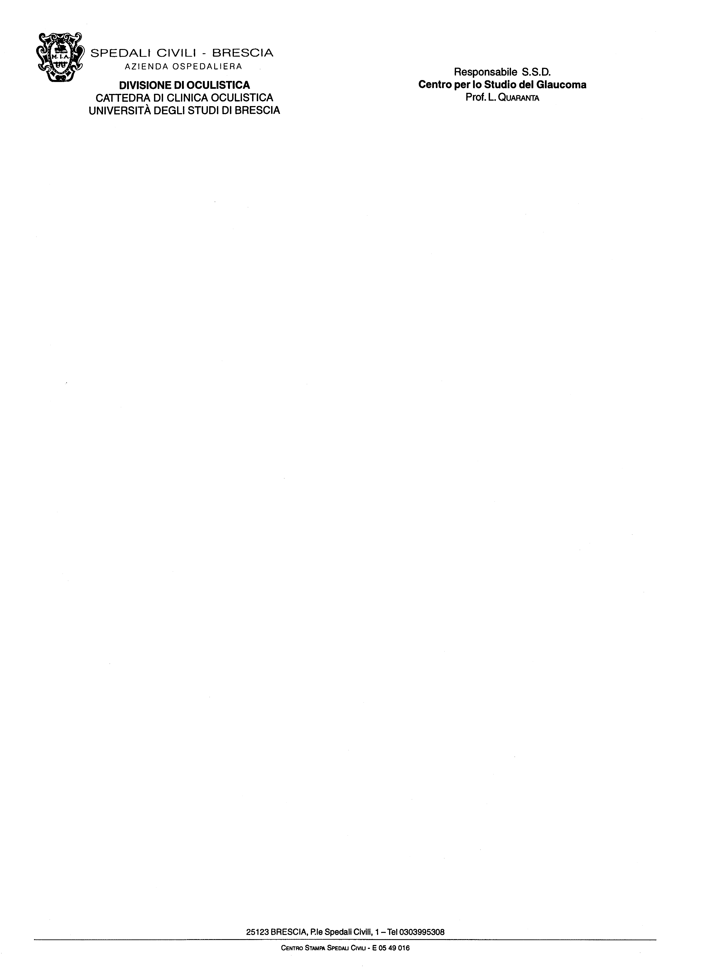

Prof. Dr. Alon Harris
Dr. Giovanna Guidoboni
Journal for Modeling in Ophthalmology

Brescia 18.02.2016

Dear Chief Editors,

I send you the short manuscript “24-hour IOP fluctuation: myth or reality?” by Quaranta L, Riva I and Oddone F for review process of Journal for Modeling in Ophthalmology.
I had full access to all the data in the study and I take responsibility for the integrity of the data and the accuracy of data analysis as well as the decision to submit for publication.

Corresponding author:
Luciano Quaranta
e-mail: quaranta@med.unibs.it
Postal Address: USVD “Centro per lo Studio del Glaucoma”
Piazzale Spedali Civili, 1
25123 Brescia, Italy
Phone Number: +390303995847; Fax: +39030396622
Sincerely,
Prof. Luciano Quaranta
